ROUTE 53

Route 53 is a DNS service

It provides HA across the region

It is a global service

If primary may fails, it will send traffic to secondary -----this is failover policy region level

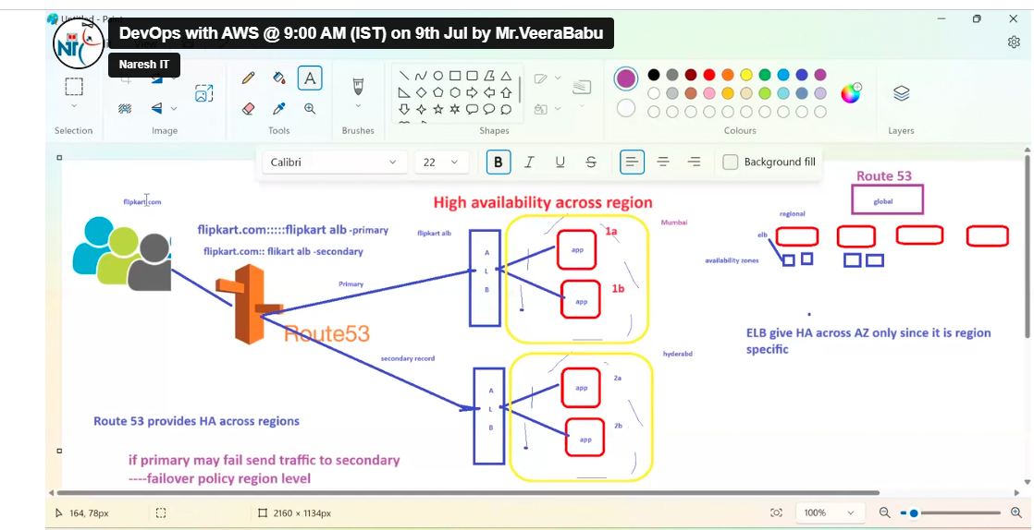

In AWS domain name service (DNS) is route 53

53 is port number

The url form ELB is nast url this is not good

So this url we should map with DNS in Route 53

In this to achieve HA we are creating two instance with same application

If 1 fails it will redirect to second one

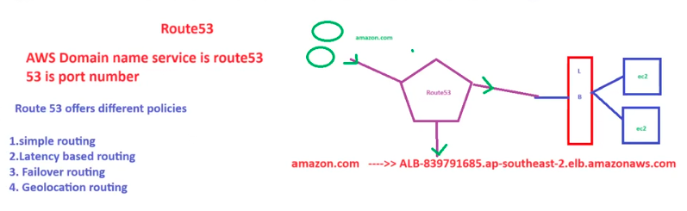

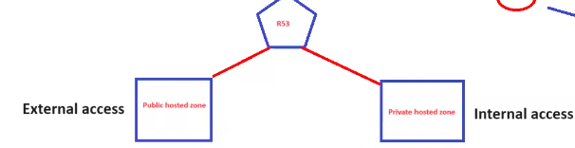

For Route 53 we have 2 hosted zones

1. Public hosed zone for external access public can access here.
2. Private hosed zone for internal access (from on VPC to other VPC)

To create Domain name some popular website like go dady

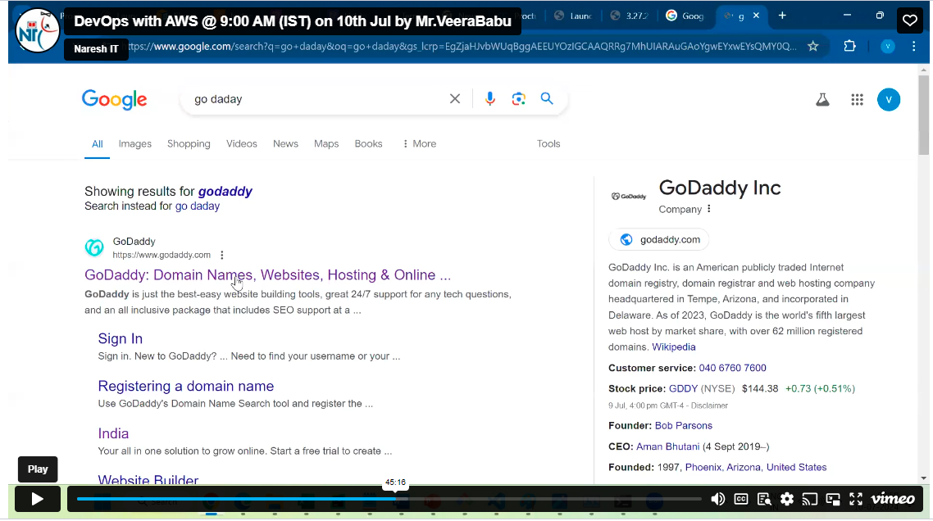

After register in go dady the records must be change in this only it works.

My product

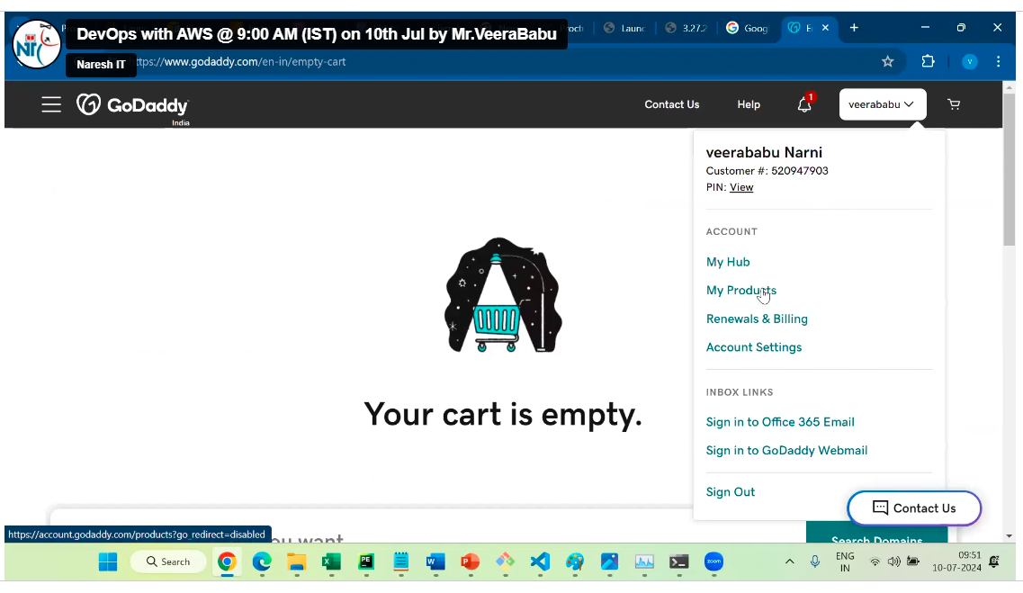

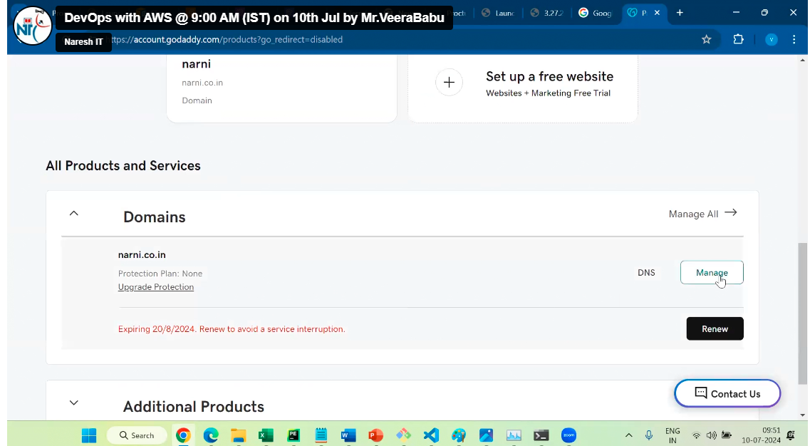

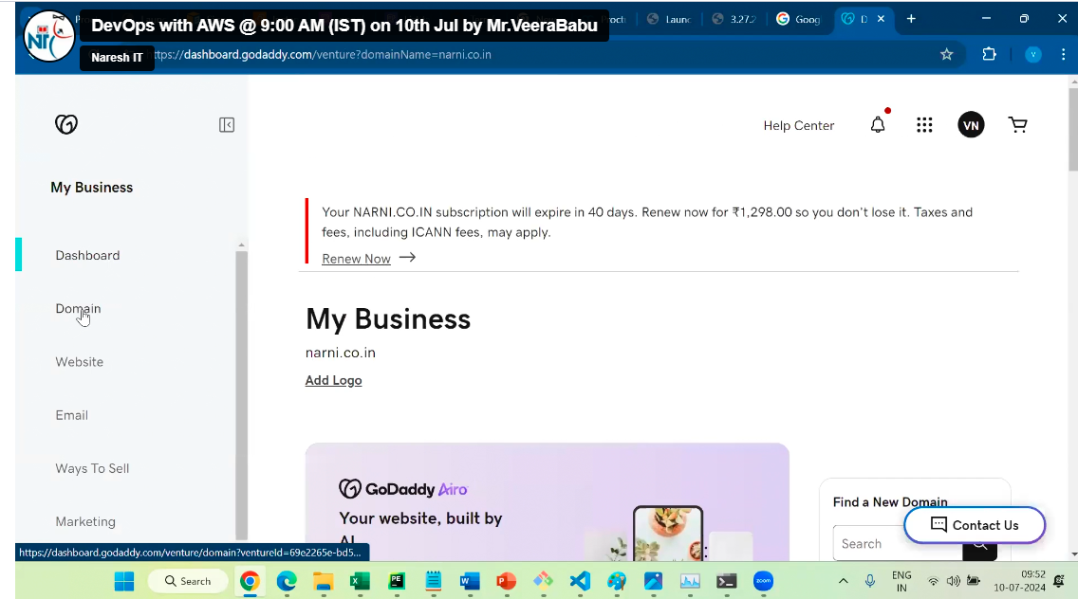

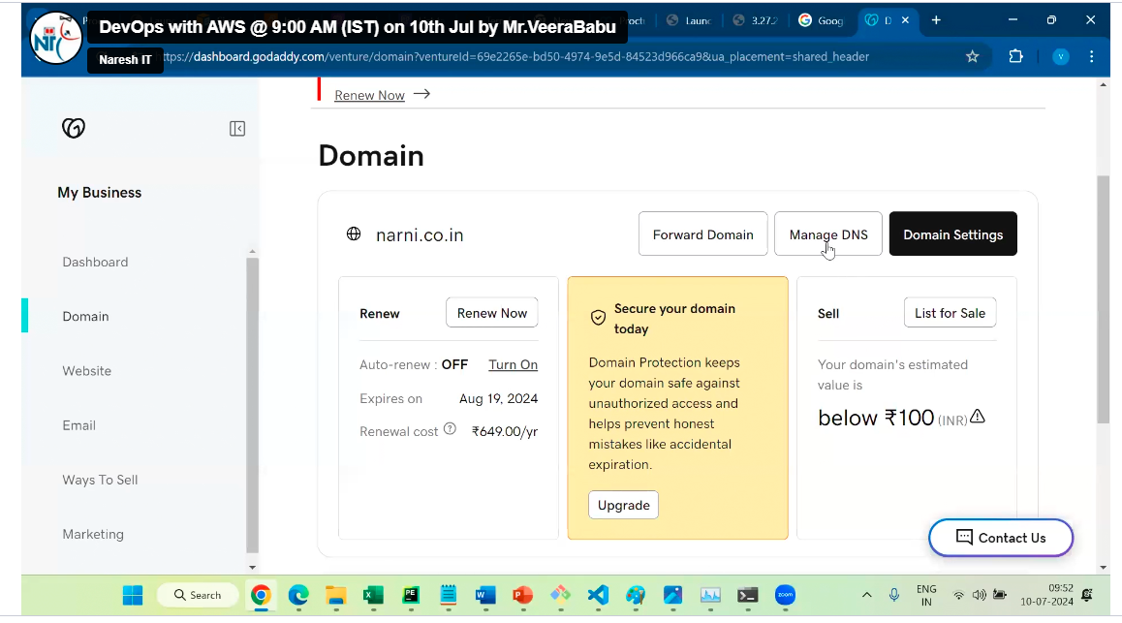

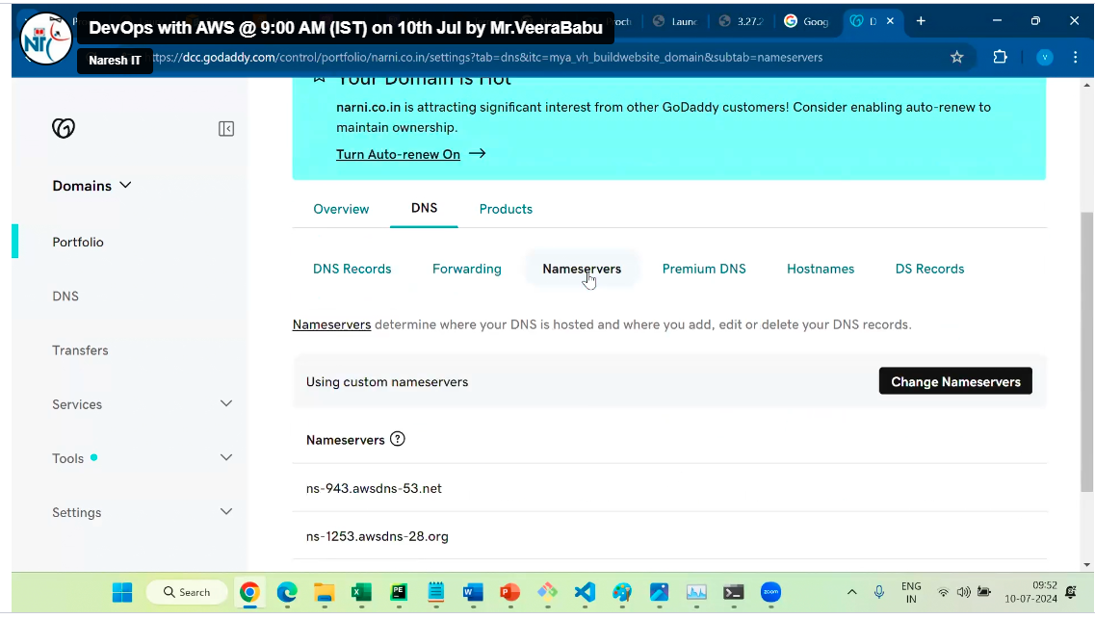

Then change here

1. Simple routing

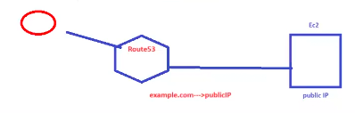

In this case no ELB is require only one public IP and Route 53, This is for only single user or we can use single ALB by enabling Alias in hosted zones

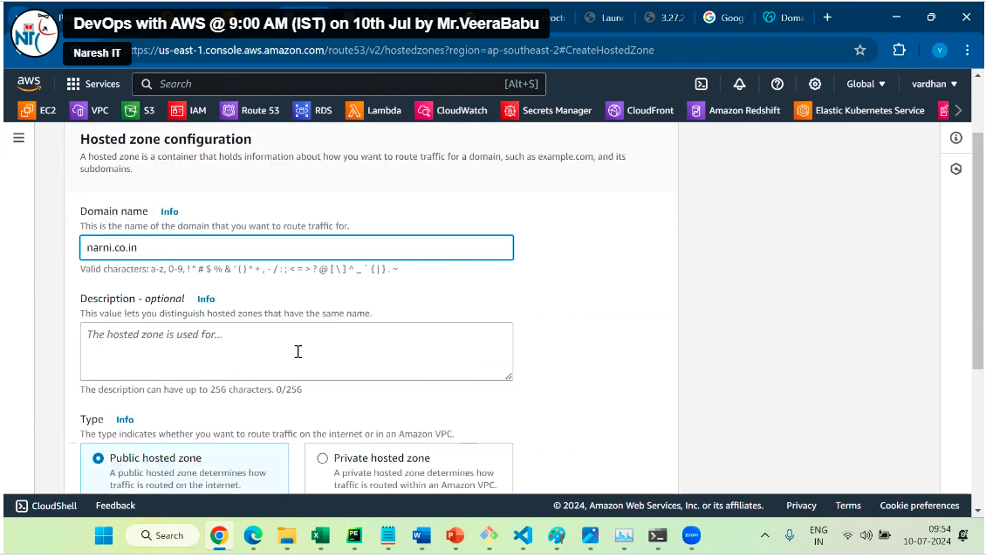

Click on create hosed zone

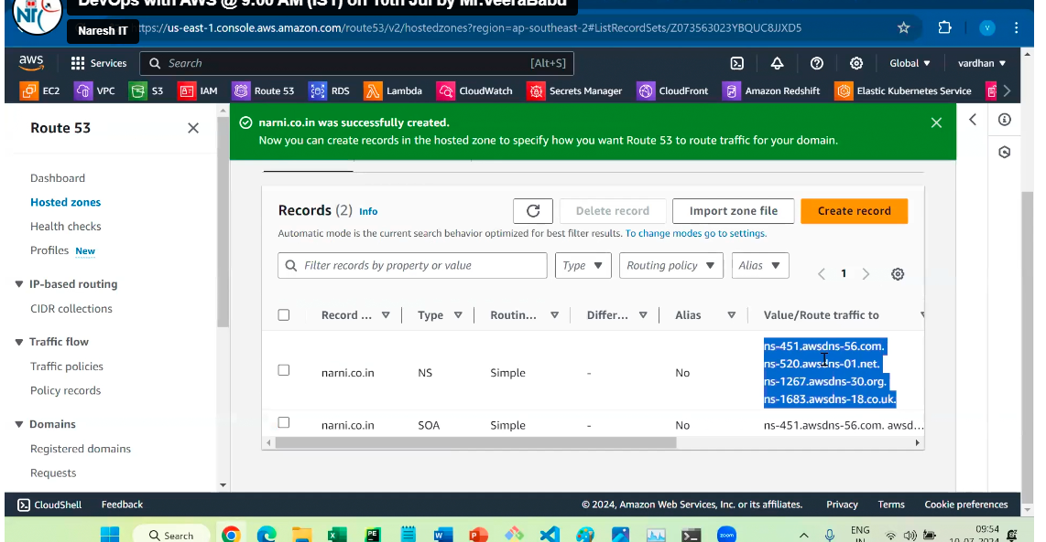

Copy this records and paste daddy do website.

Don’t copy . at end

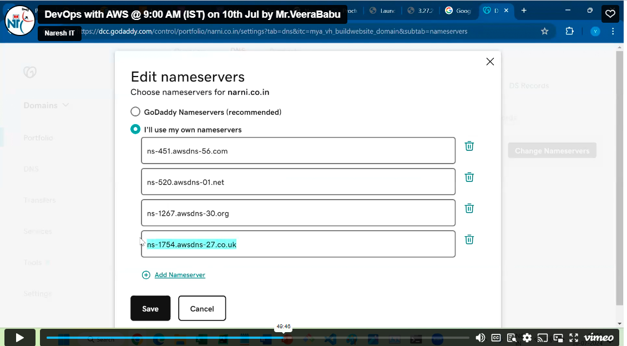

Now register dns is communicate to route 55

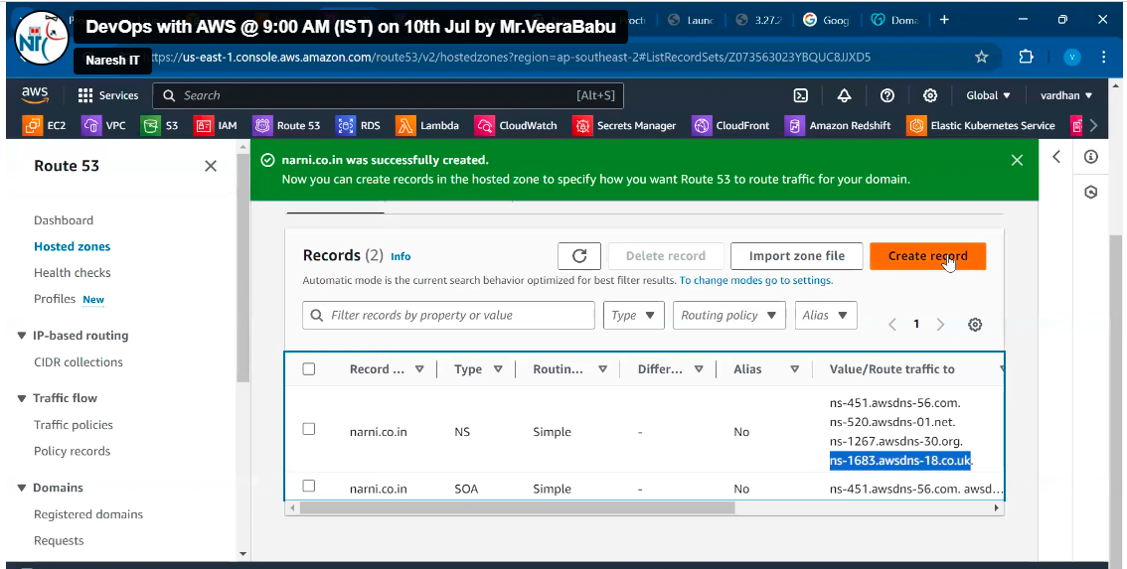

Here public IP of the server

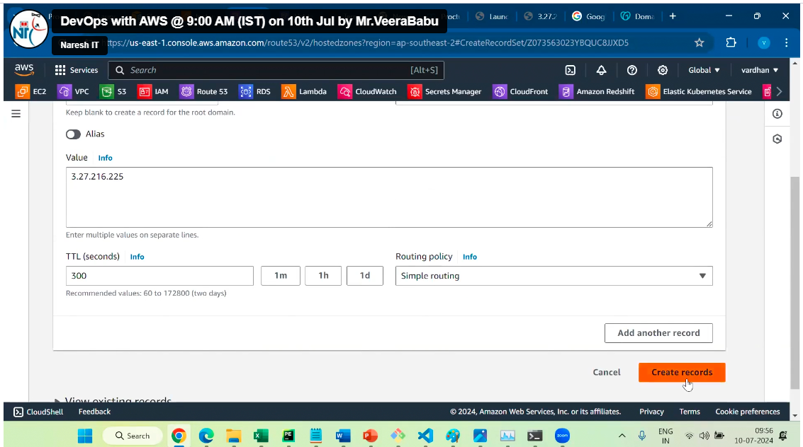

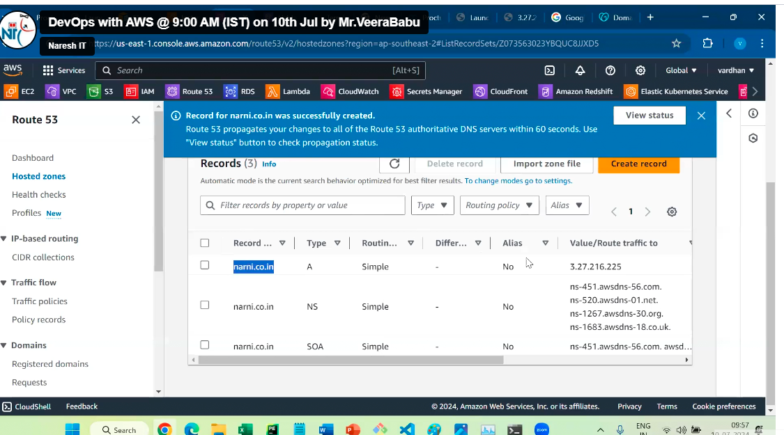

Copy from above



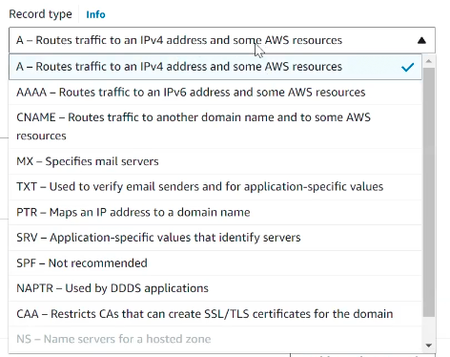

We can do this by ALB also

We need to on Alias for this process

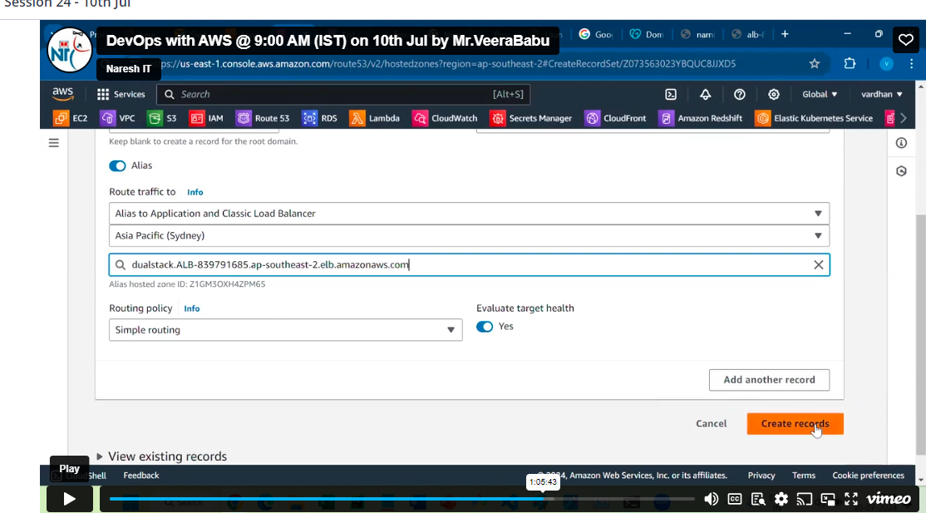

1. Latency based routing

In this case, we required two ALB in different regions or only two instance from different regions (ex: Mumbai, America)

We need to on Alias for this process

In latency, based routing it enables the request near region



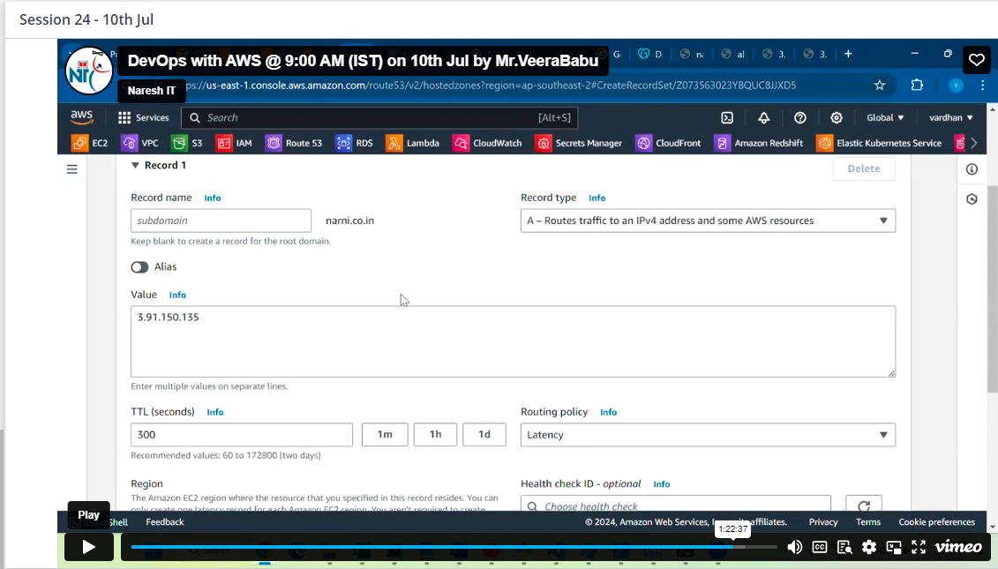

Then create the record two for other location with IP as above

Then the near person at the region can get the result from near region only

